FILE ORGANIZATION

Where to save a file?
All client artwork should be saved in the month’s folder when the art was created.
Example: If the artwork was created in the month of August, the file should be saved in the 08-20XX folder. The proof’s Disc. location should also reflect where the file is saved.

How to name a file?
First word of the organization followed by the next 3 initials of the rest of the organization. Next
is the file type. Last is the PO.
Example: Organization name is Elevation Community Church - Blanchester, OH. PO is 69249.
The art is a CSA. So the filename would be:
ELEVATION CCB CSA 69249
File Types:
CSA - customer supplied art, recreates
HR_5 - concept job that is less than an hour
HR - concept job that takes an hour
2HR - concept job that takes 2 hours
TEMP - template
FM - face mask
CZ - coolyz
WTHPS - woothoops
ASI - in house and outsourced promotional items
EMB - embroidery only
Note: When saving a Photoshop file, make sure to name the file the same as the Illustrator file.
Example:
ELEVATION CCB CSA 69249.ai
ELEVATION CCB CSA 69249.psd

When creating a new version for a PSD file, re-save the file with a lettered version. DO NOT OVERRIDE THE ORIGINAL FILE.

Example:
ELEVATION CCB CSA 69249_A.psd
ELEVATION CCB CSA 69249_B.psd

Saving a File

1. Click on the Opportunity, which will direct you to the Art Request Form (ARF).
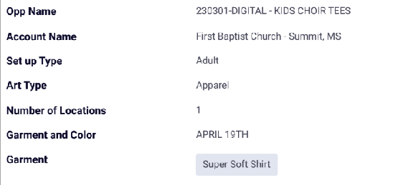
2.In Salesforce, go to the ARF and take a screenshot of the mock up information. Make sure you scroll down to the bottom of the page to make sure you aren’t missing any information
3. Go to the New Apparel Mock Up.ai and paste the ARF. Name your file accordingly as mentioned in the Art Book and make sure you save your file to the current month.

4. When artwork creation is done, Pre-Flight. Make sure your art fits within print specifications and your export settings resemble this image below.
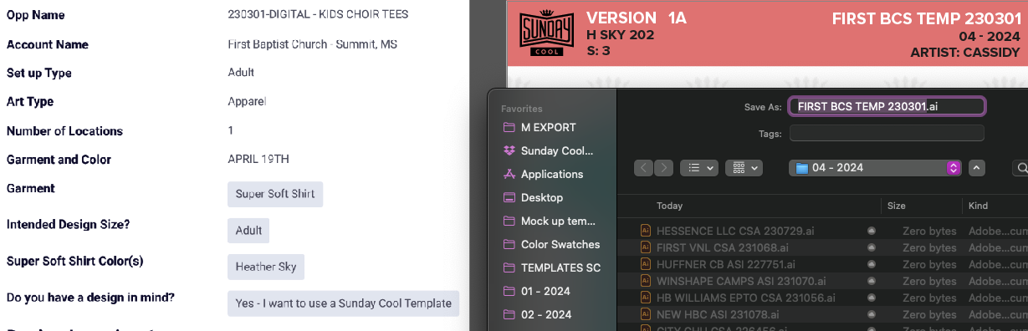
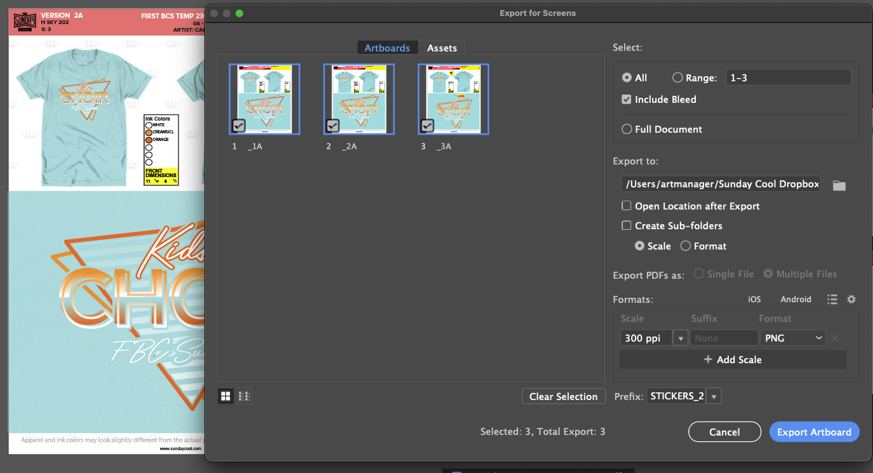
5. Send artwork to proof channel for internal approval.

